STEP 1: START THREE INSTANCES

1 -> ANSIBLE MASTER

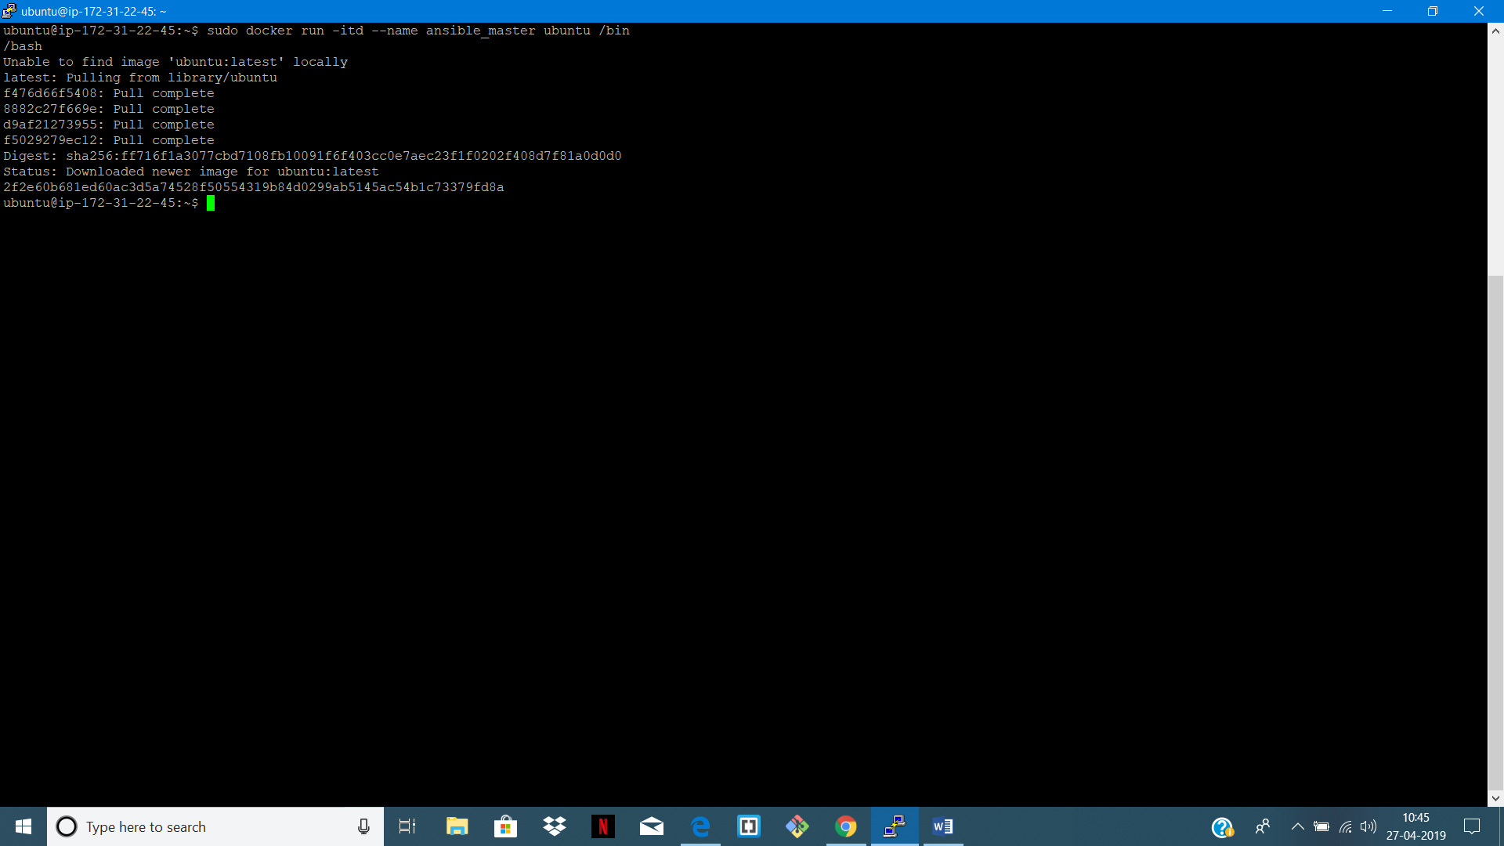

2 -> TARGET 1 and TARGET 2

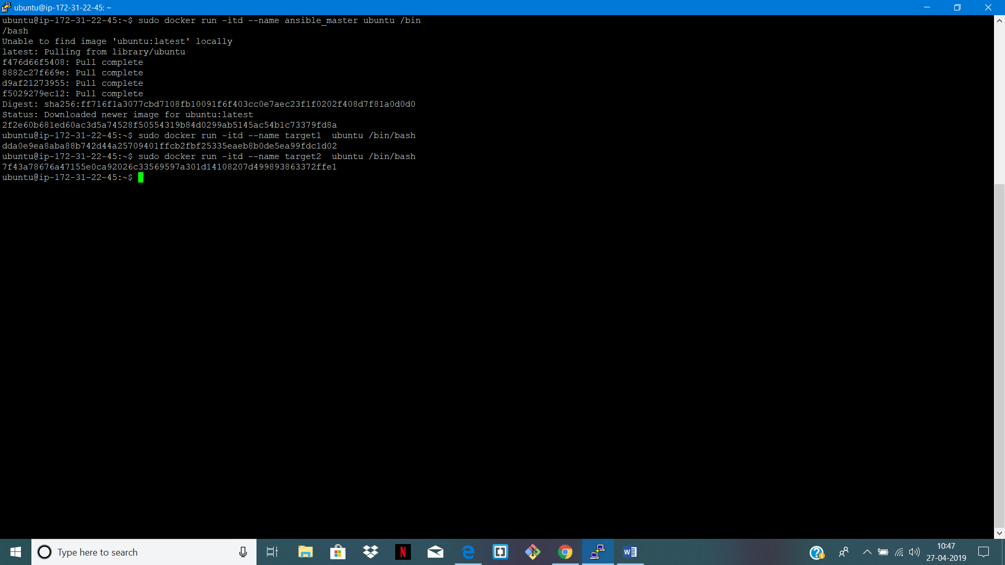

STEP 2: WE SEE ALL THREE INSTANCES

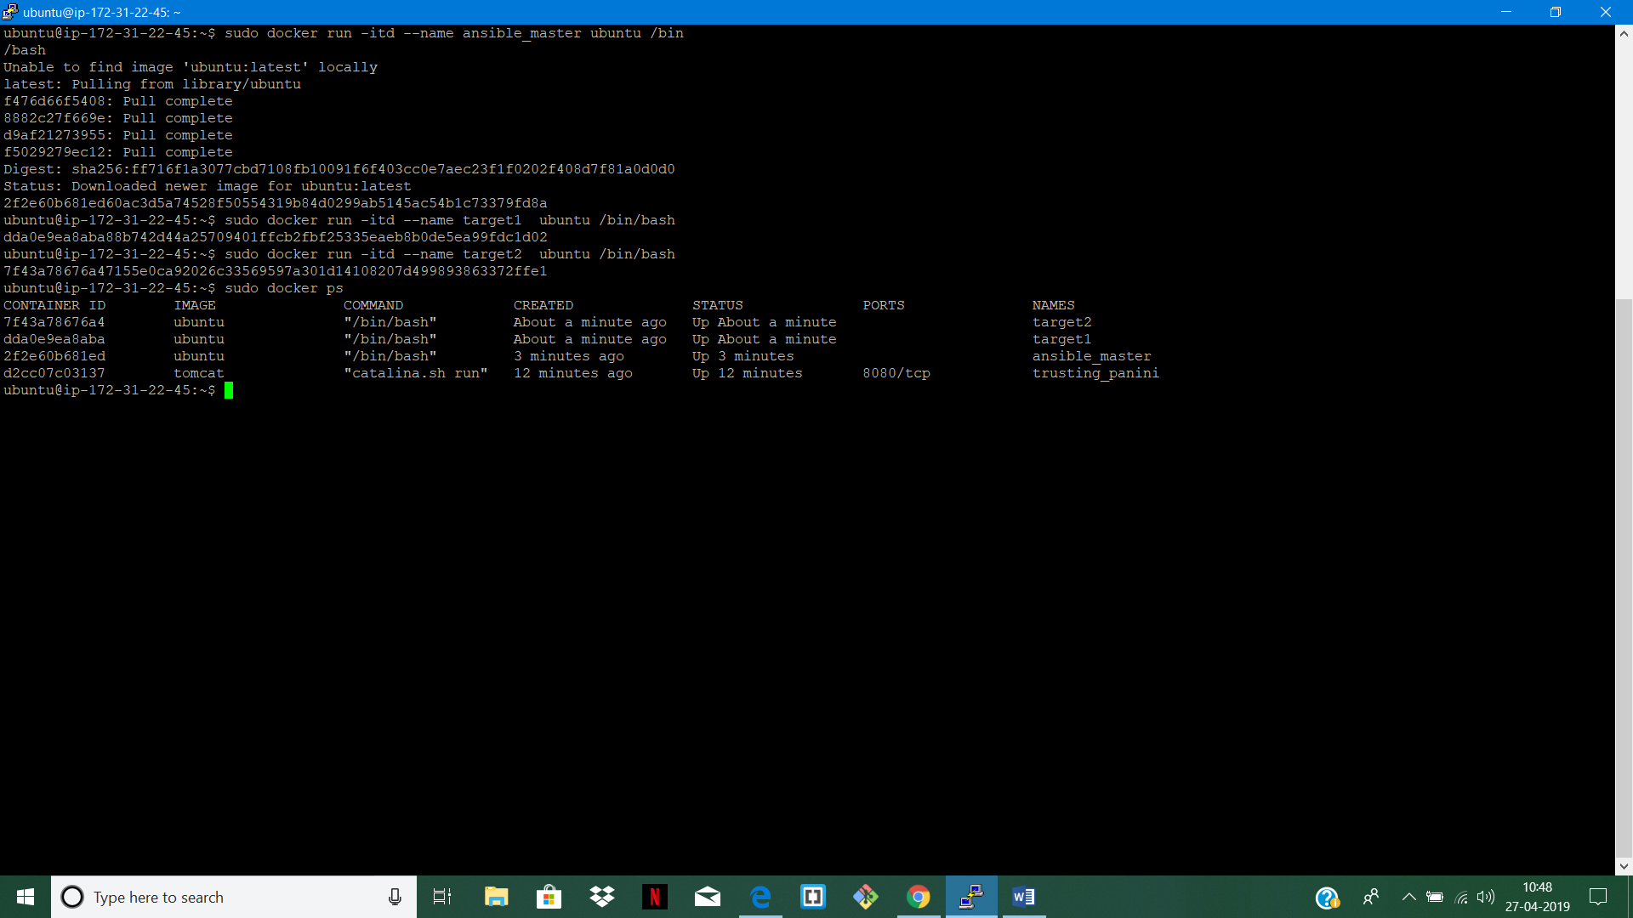

STEP 3: INSTALL ANSIBLE INTO ANSIBLE MASTER

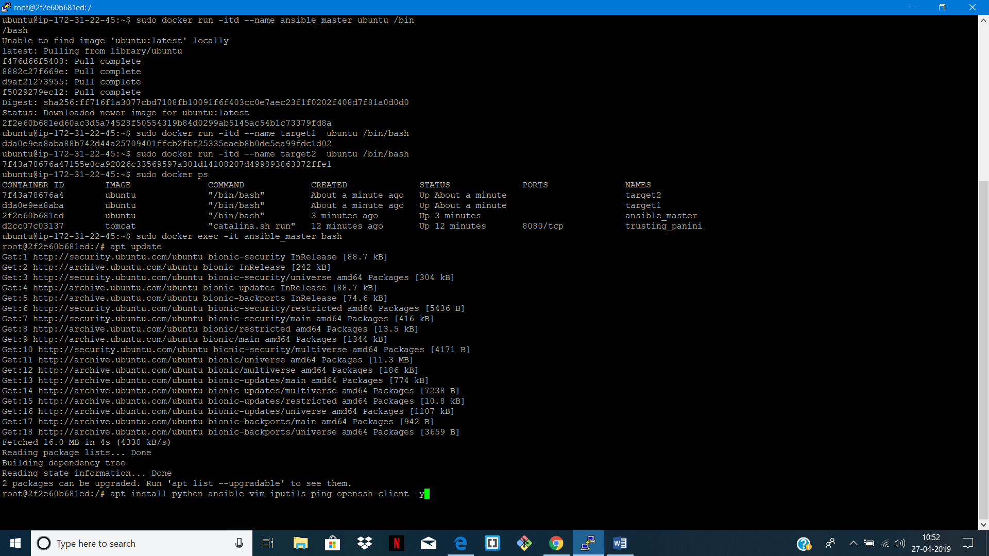

STEP 4: CHECK ANSIBLE VERSION

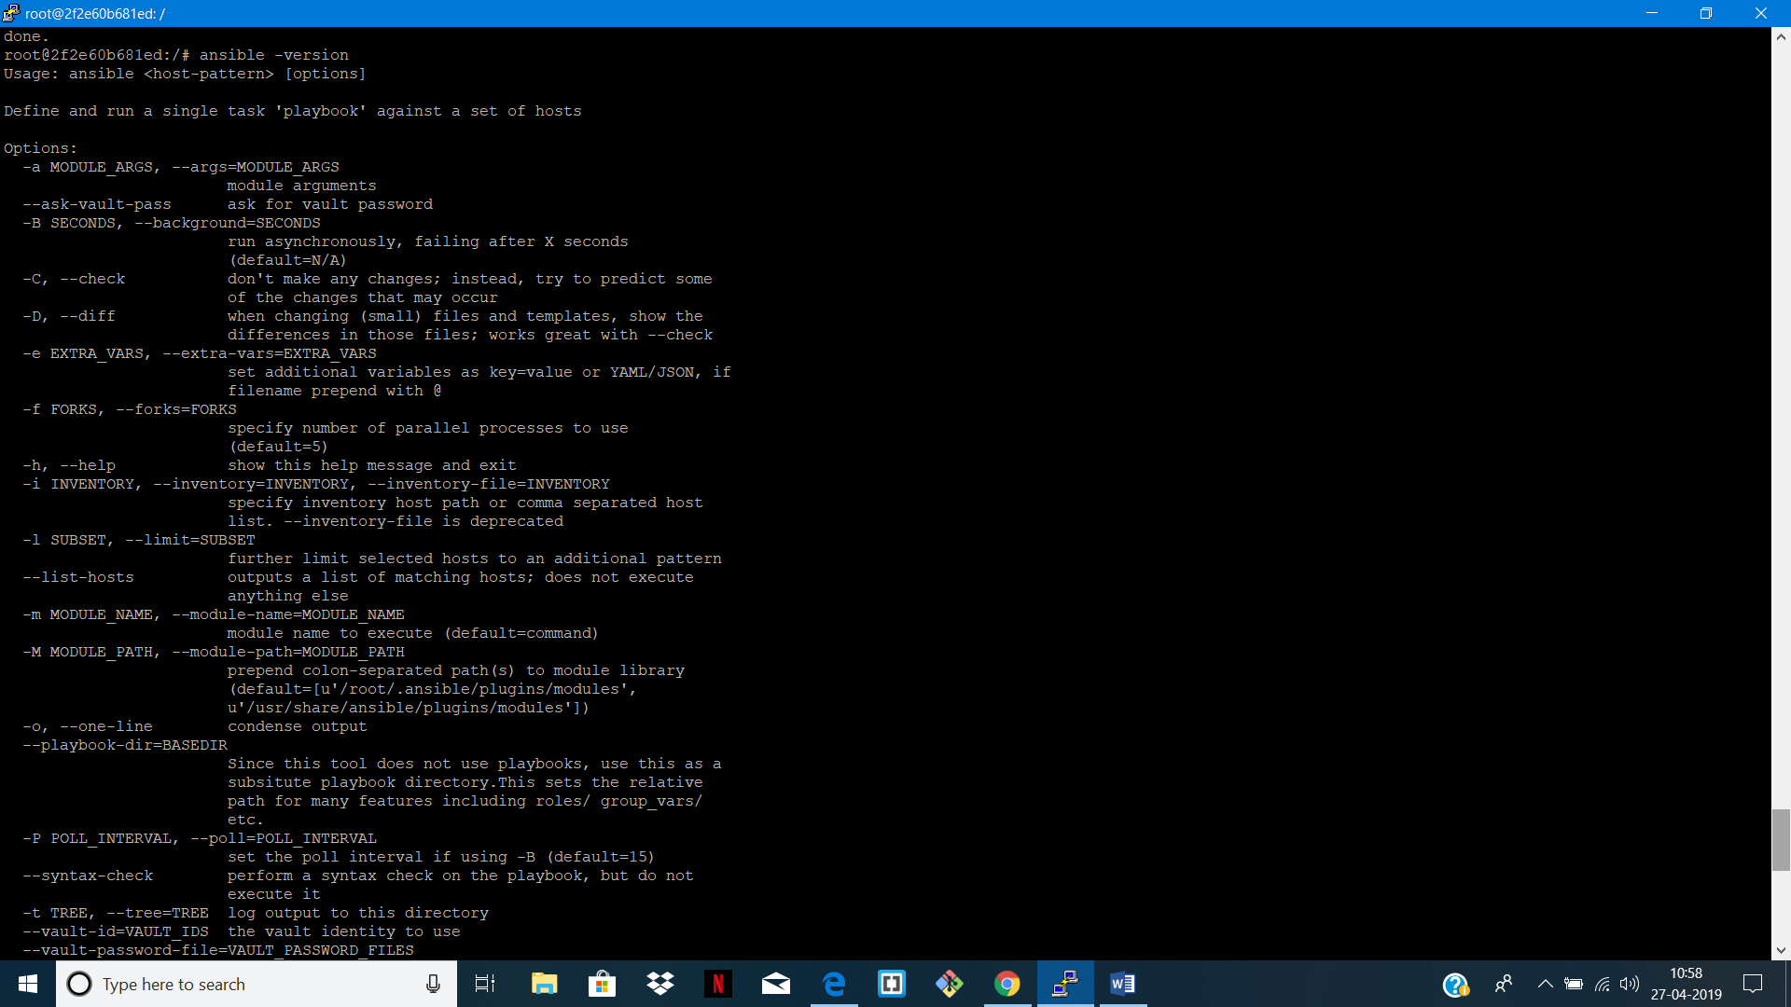

STEP 5: EXIT ANSIBLE AND GO TO TARGET 1

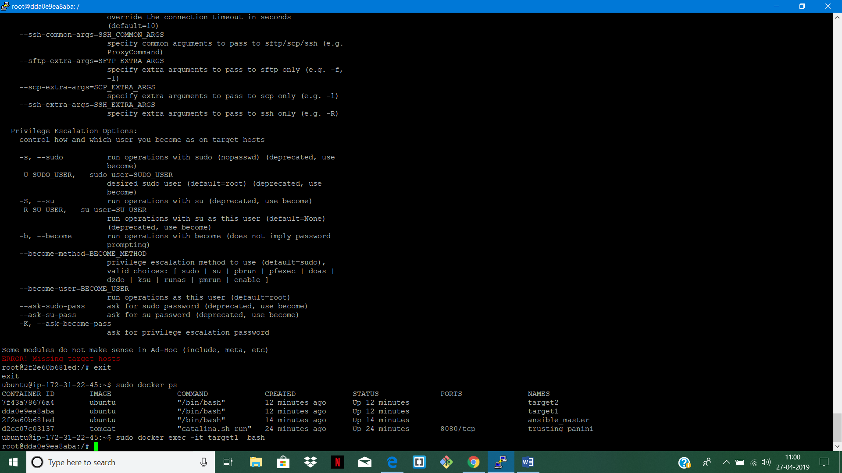

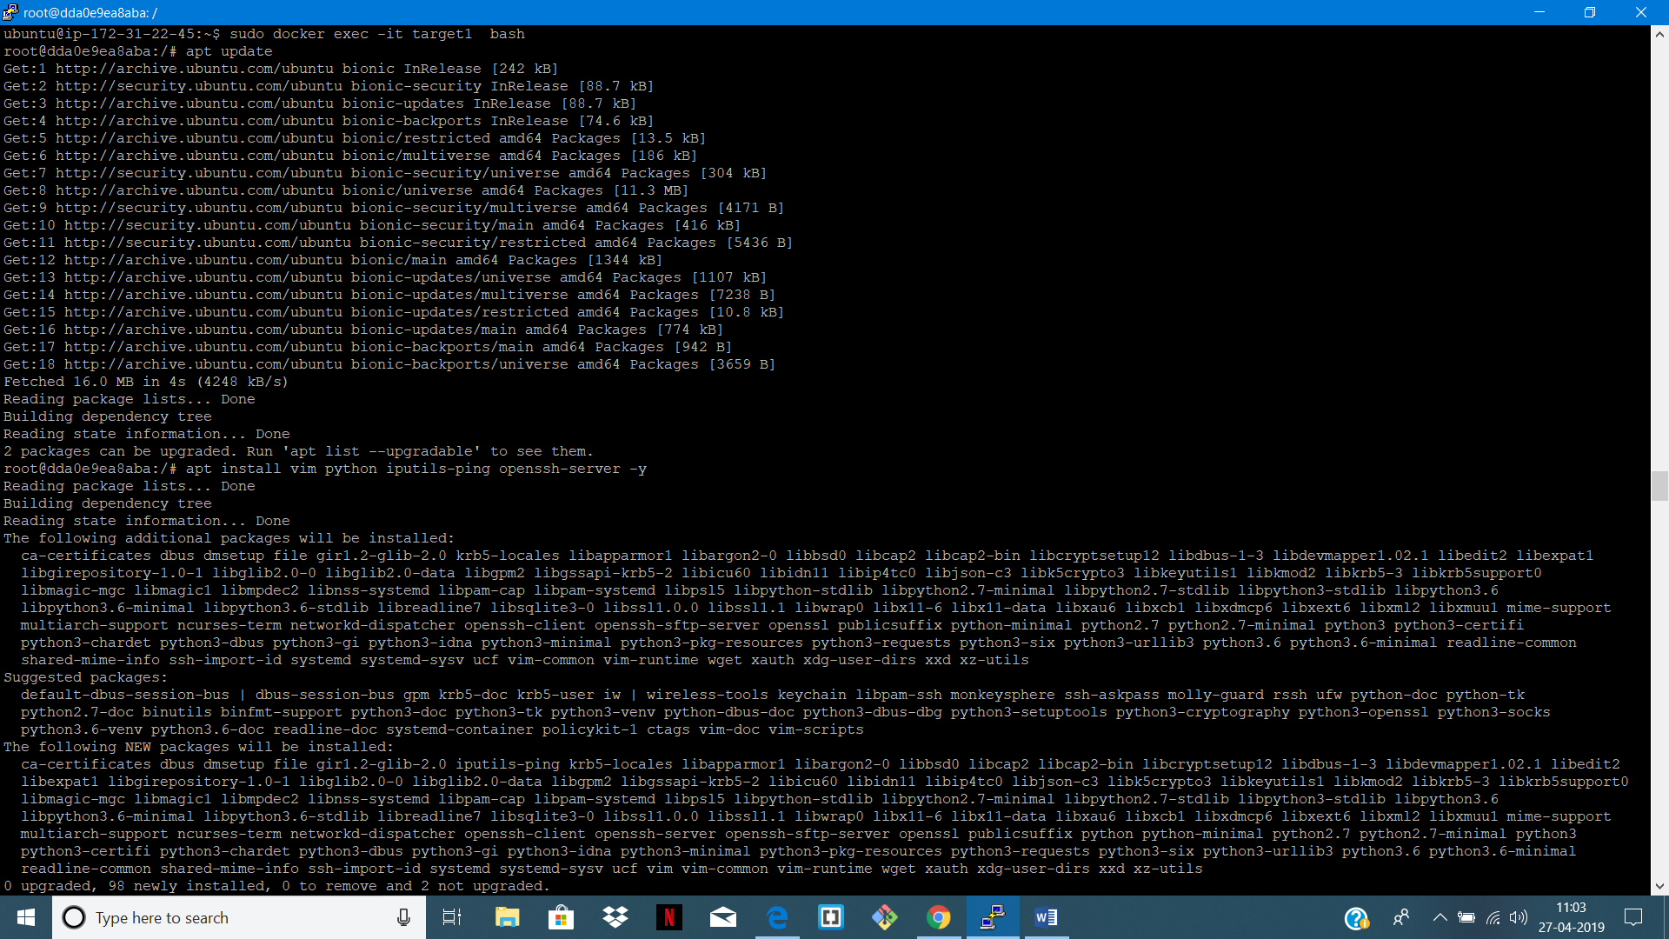



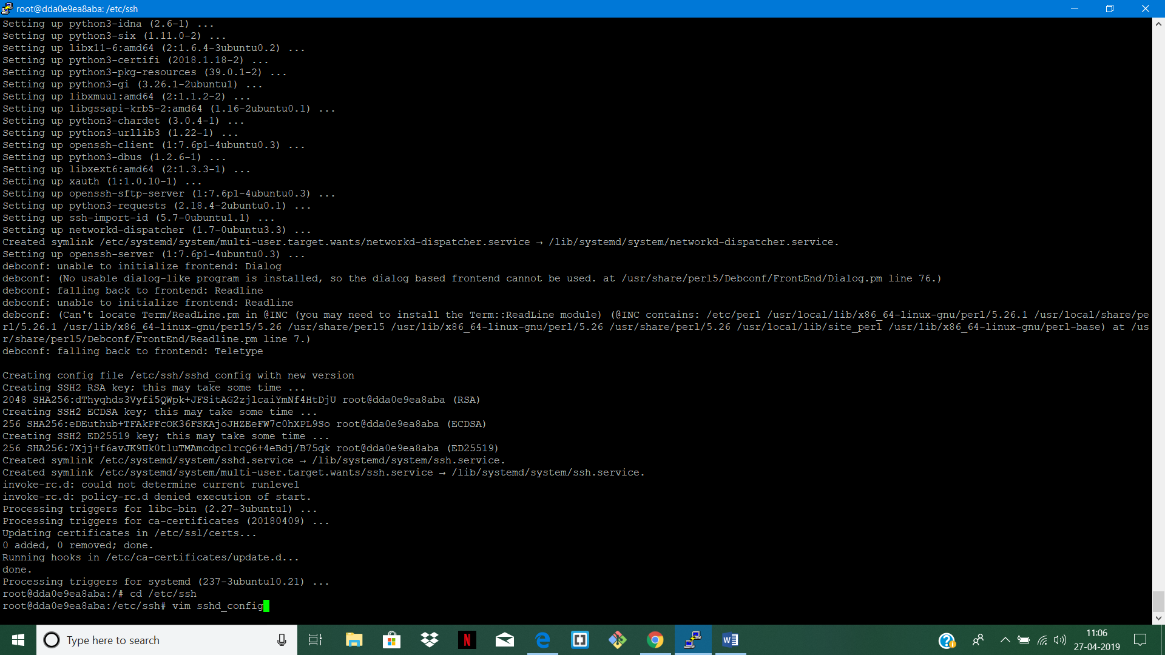

STEP 6: REPLACE PROHIBIT-PASSWORD WITH YES AND REMOVE COMMENT

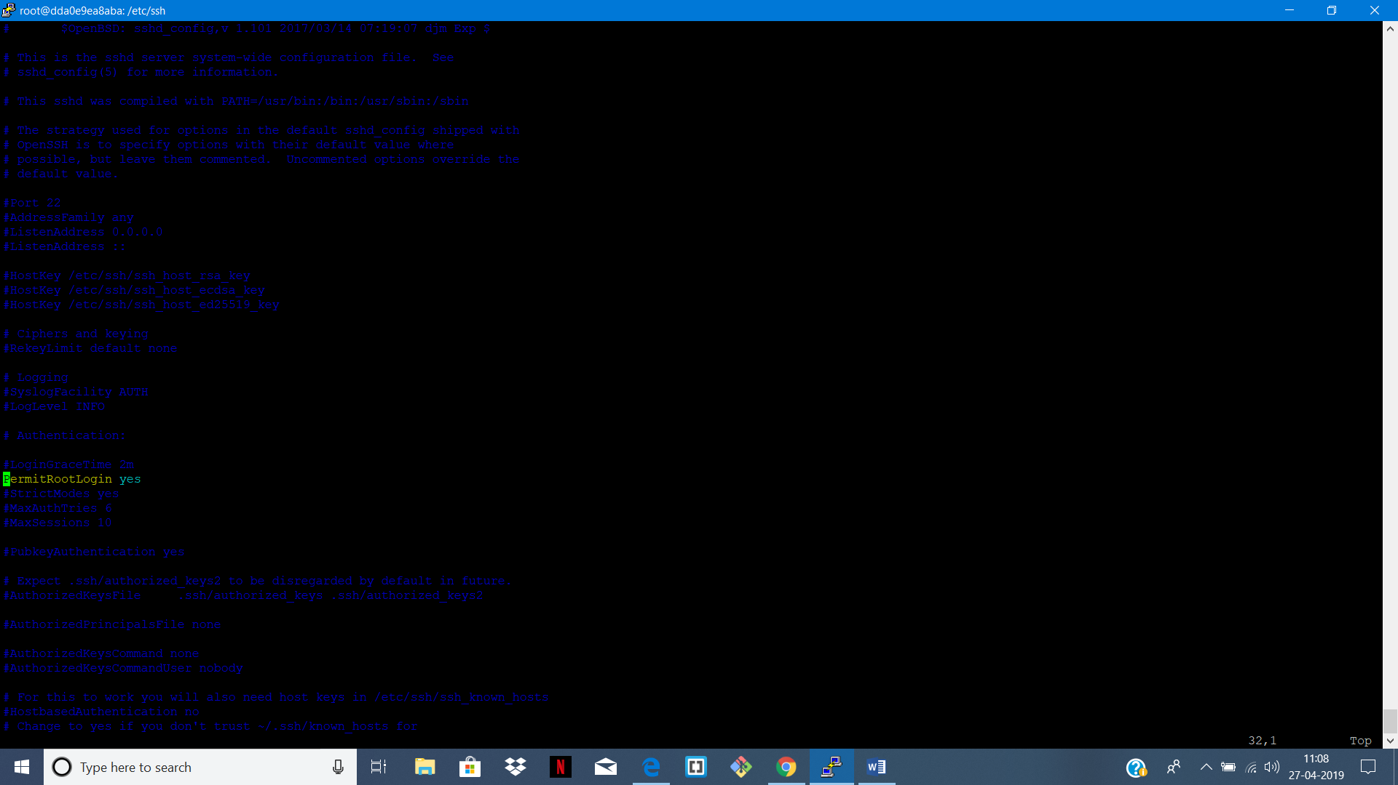

STEP 7: RESET PASSWORD OF THE ROOT

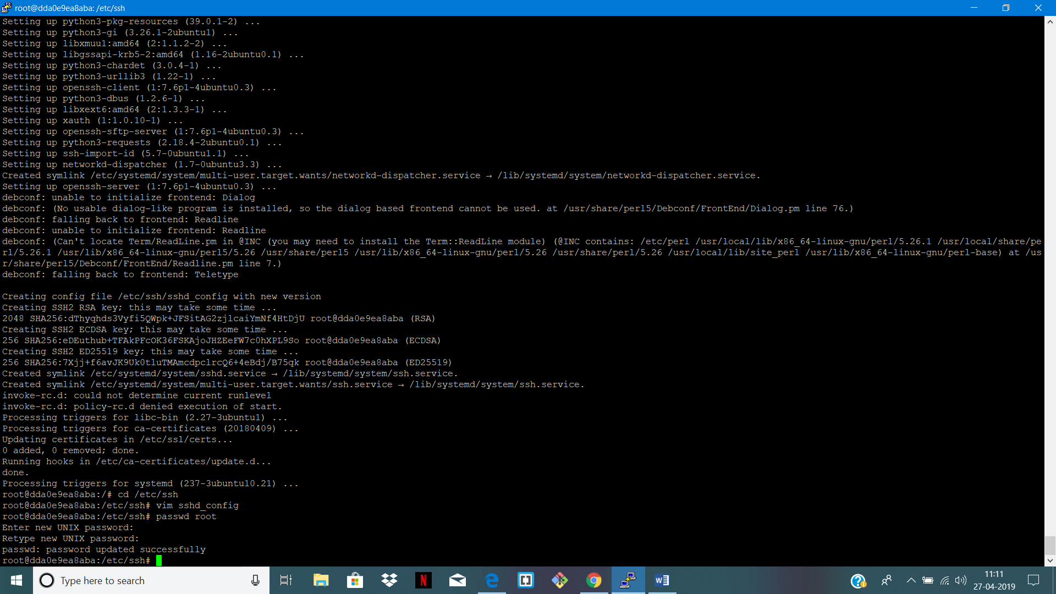

STEP 8: RESTART SSH SERVICE

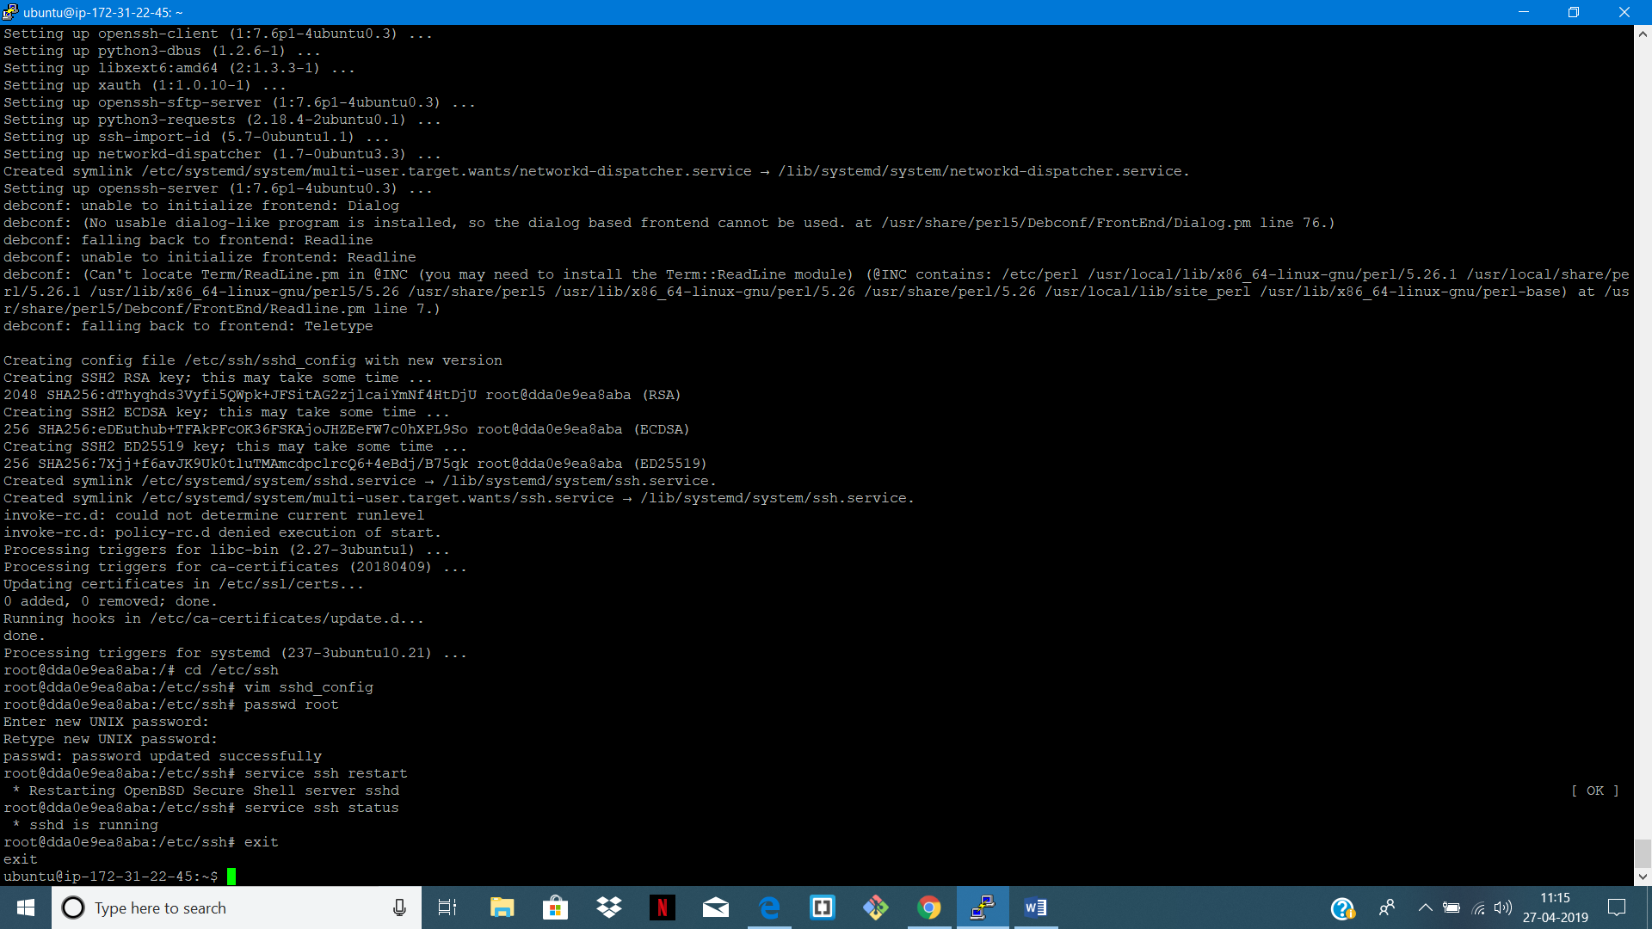

// DO THE SAME FOR TARGET 2 (STEP 5 -> STEP 8)

STEP 9: CHECK IP OF BOTH TARGETS

FOR TARGET 1 : sudo docker inspect target1

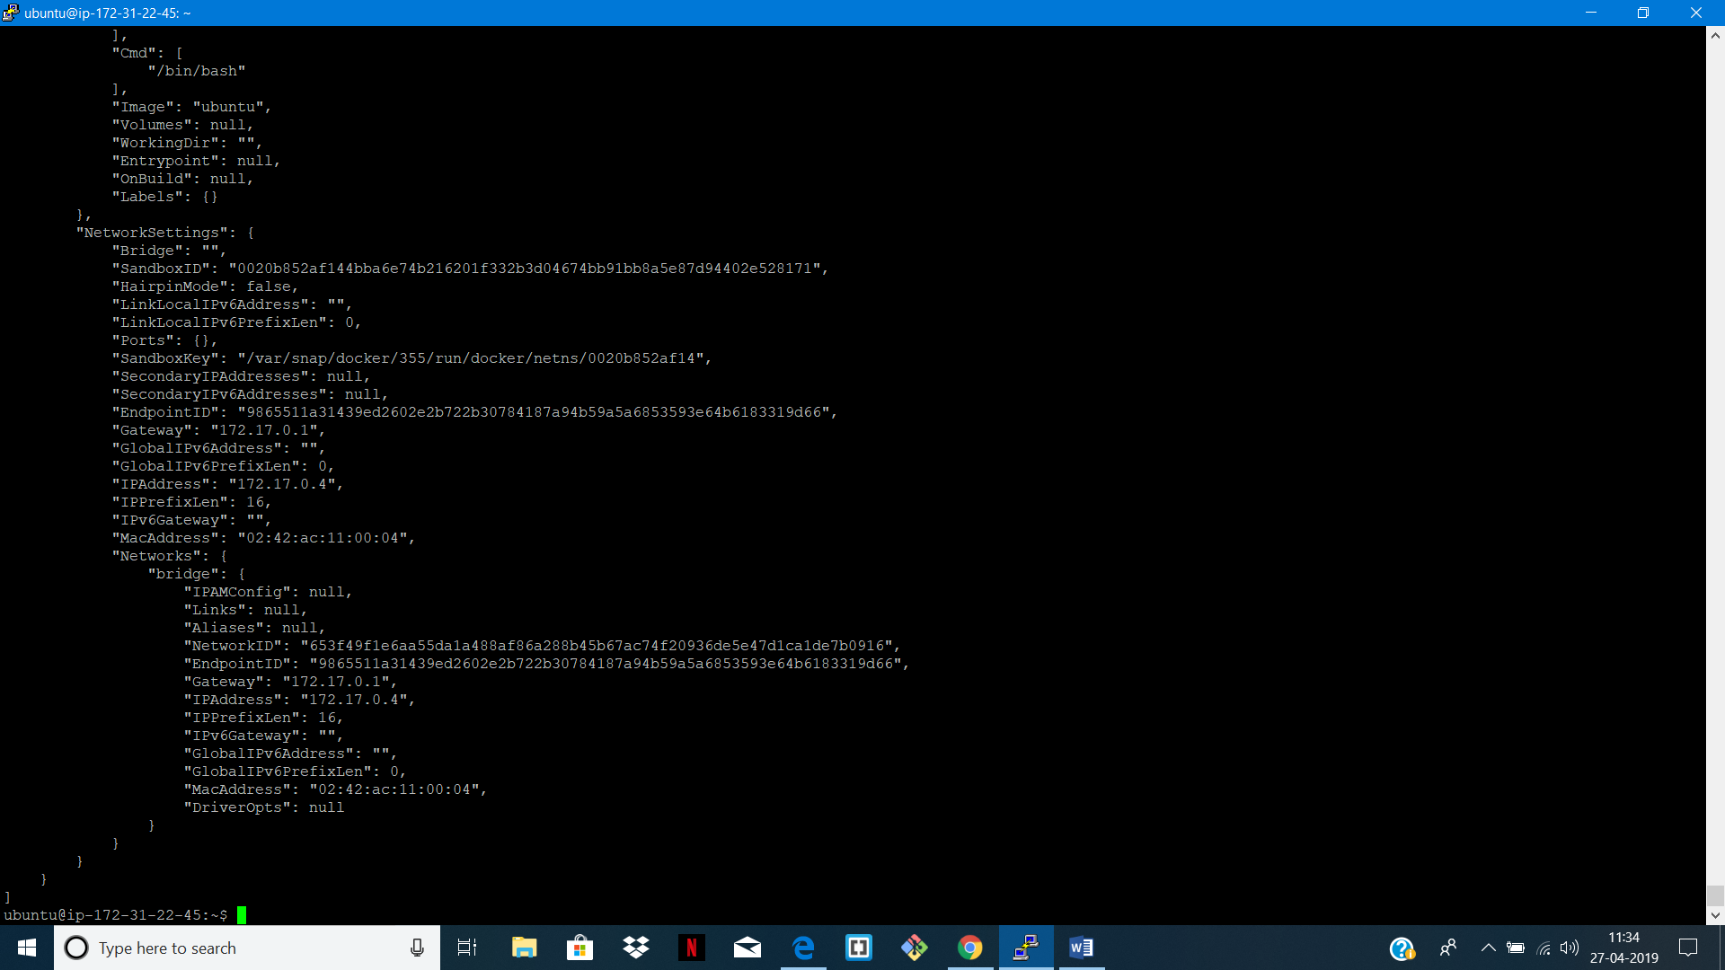

FOR TARGET 2 : sudo docker inspect target2

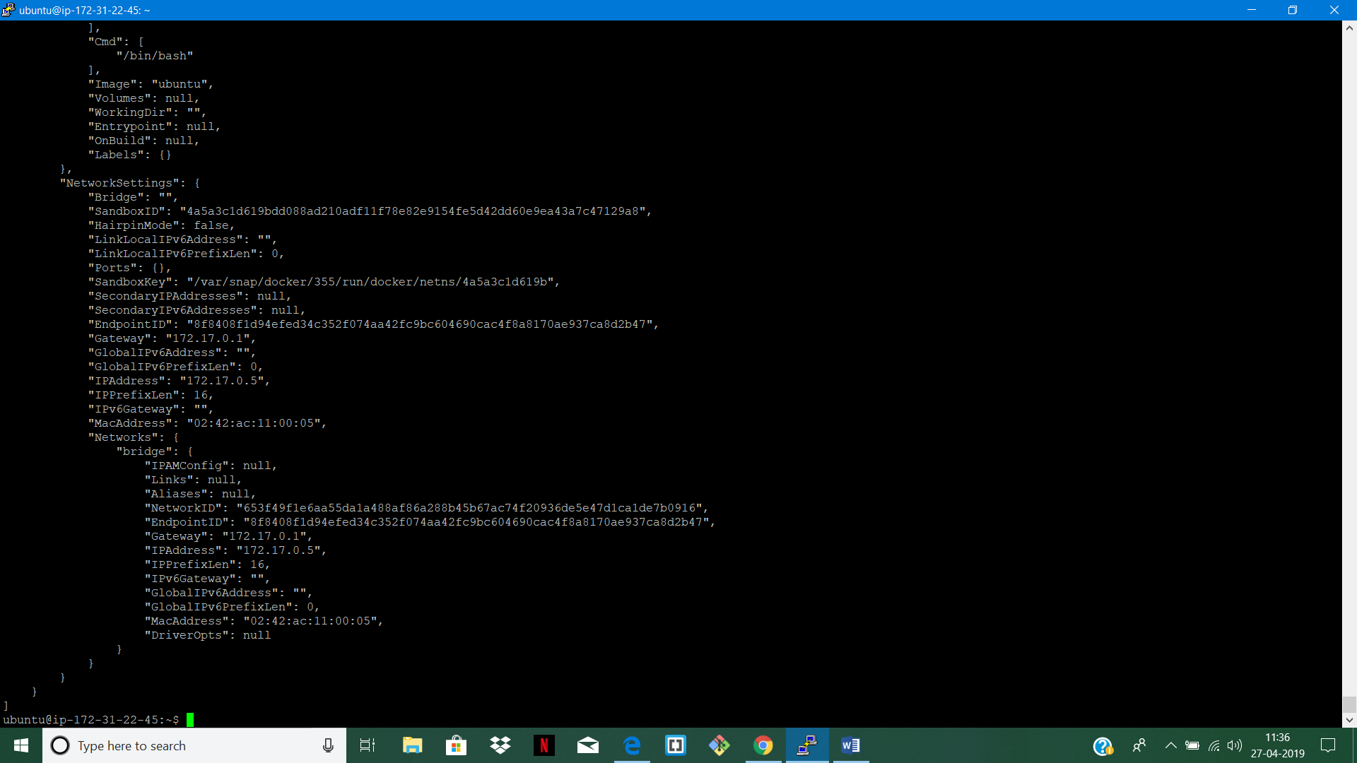

STEP 10: GO TO HOST FILE

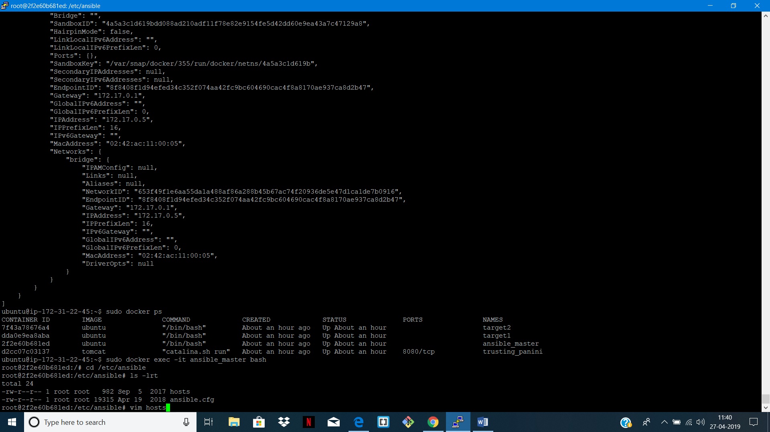

STEP 11: ADD IP OF BOTH FILES TO HOST

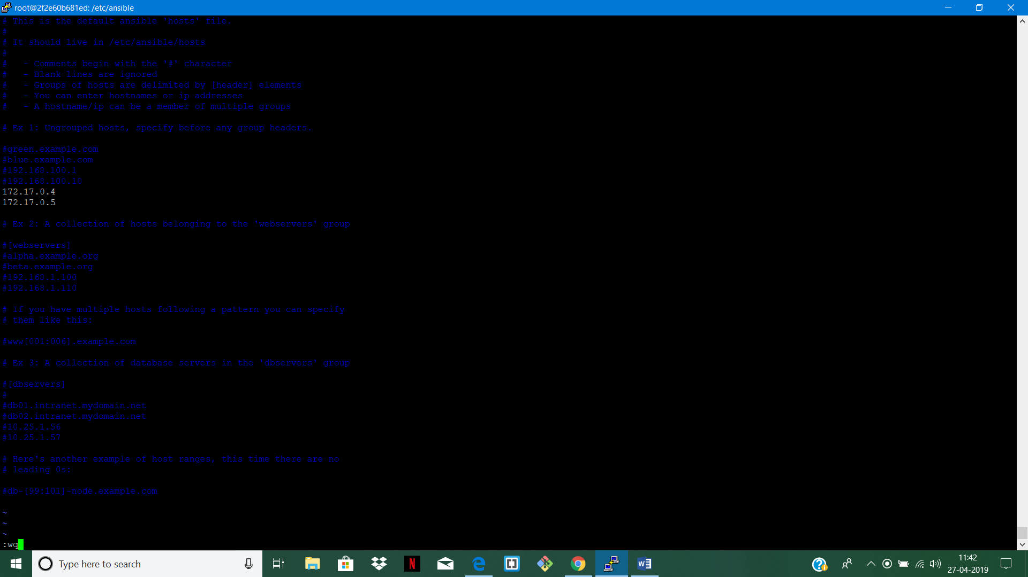

STEP 11: PING BOTH THE FILES

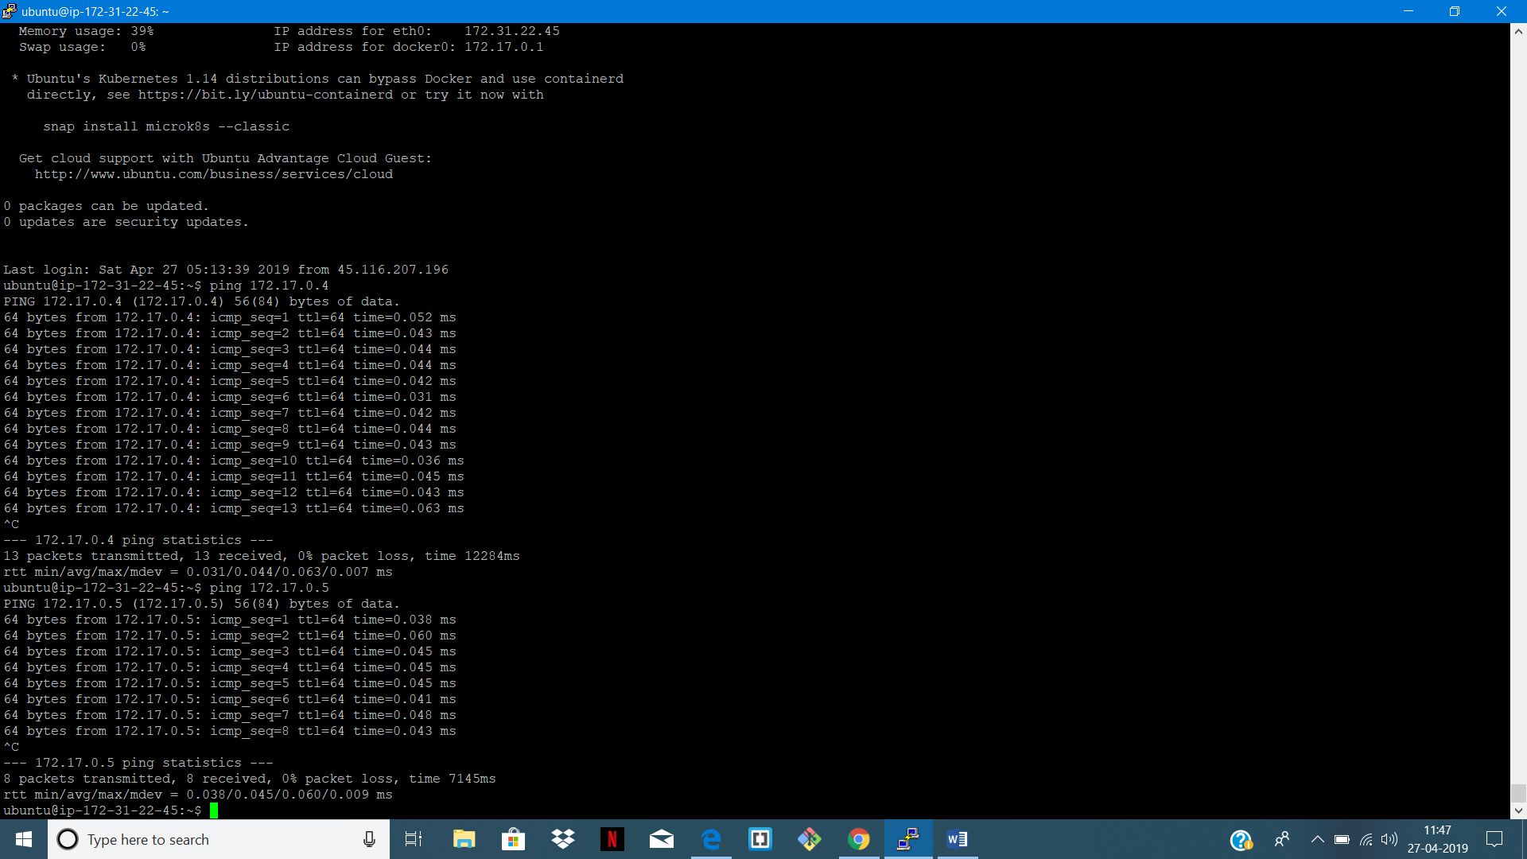

STEP 12: GENERATE SSH KEYS

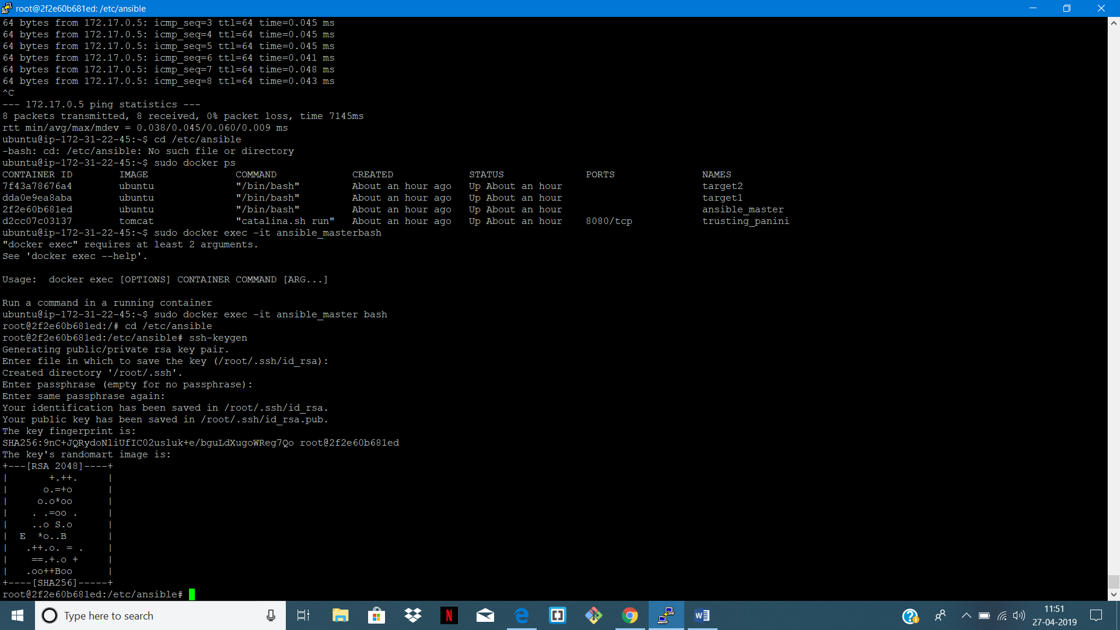

STEP 13: COPY KEYS TO BOTH THE TARGETS

FOR TARGET 1:

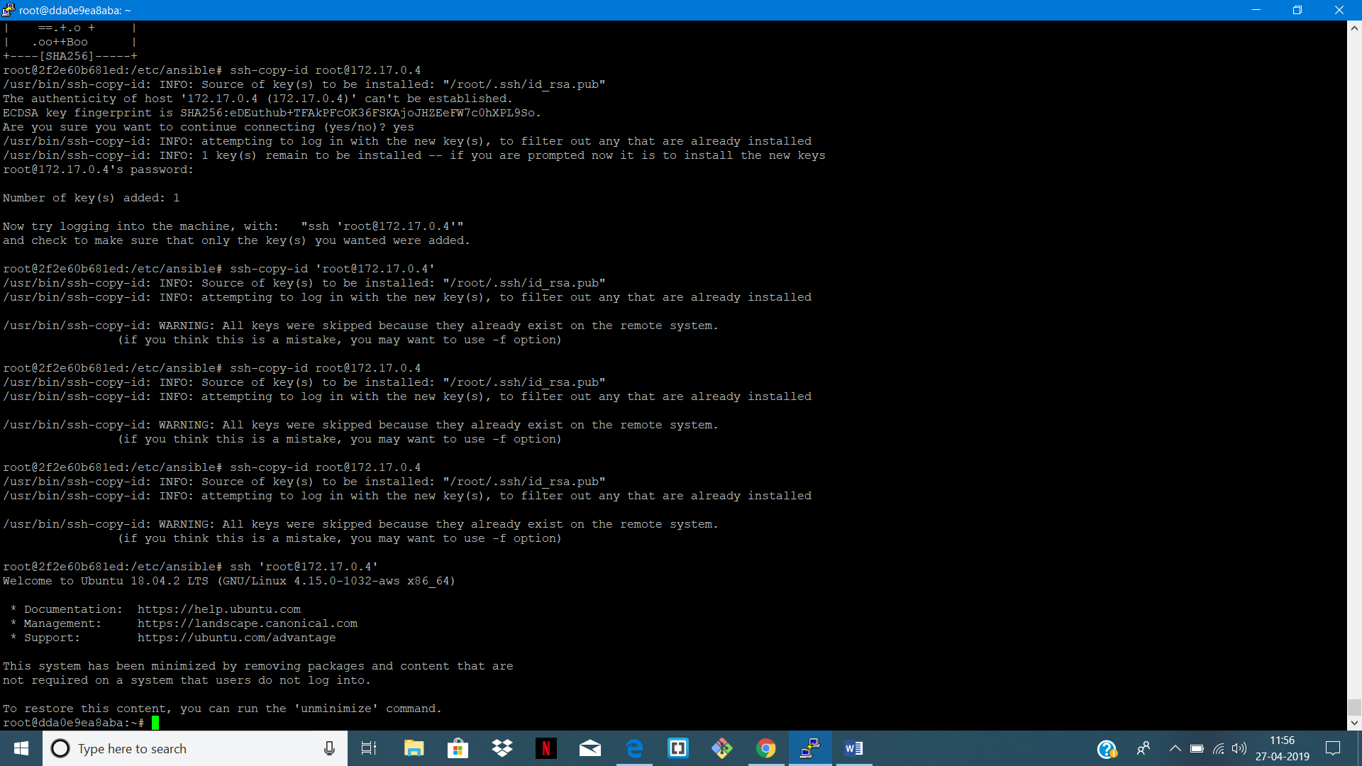



// DO THE SAME FOR TARGET 2

STEP 14: CREATE PLAYBOOK BY COPING THE FILE TO VIM

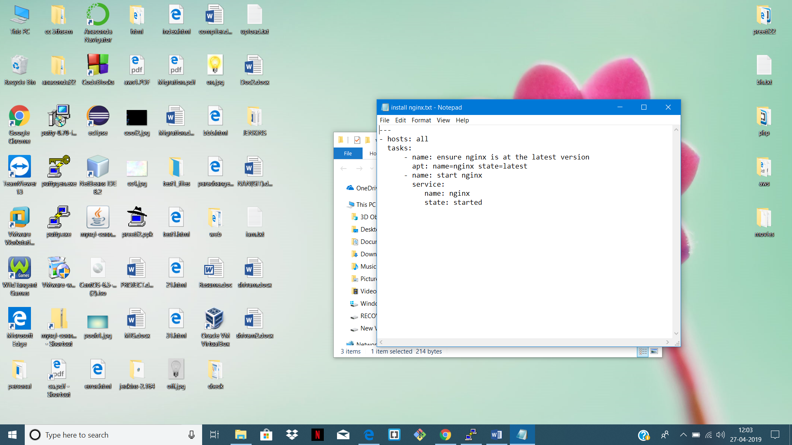

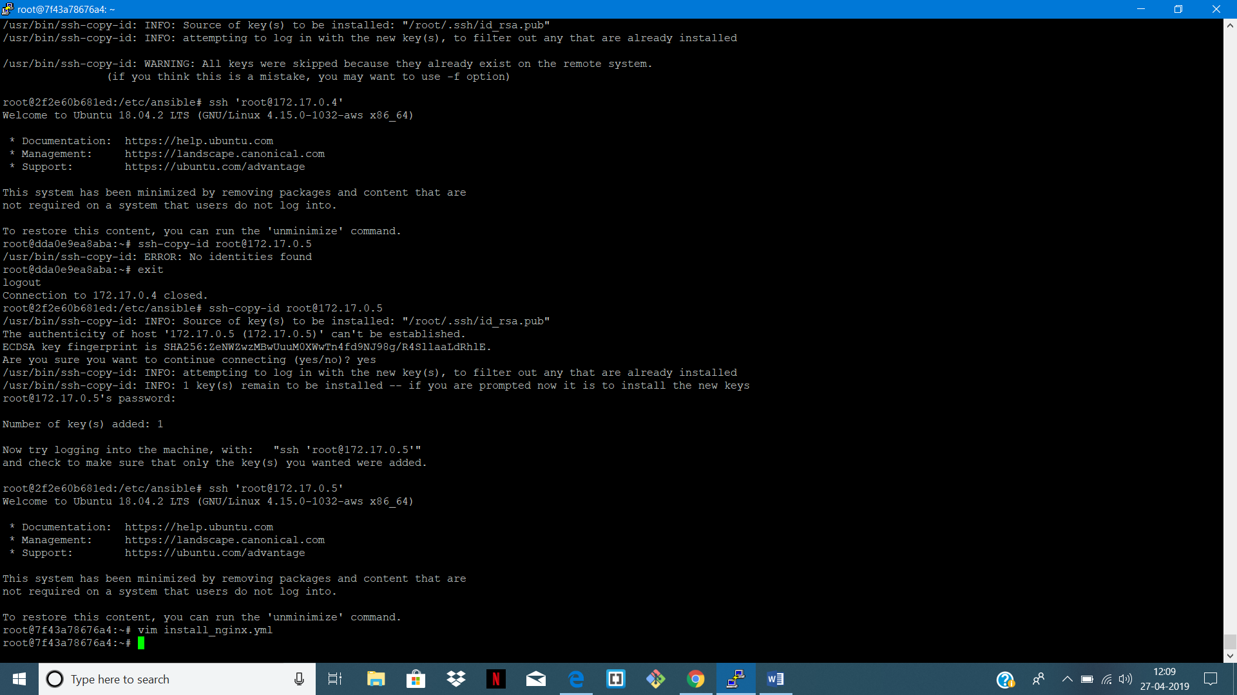

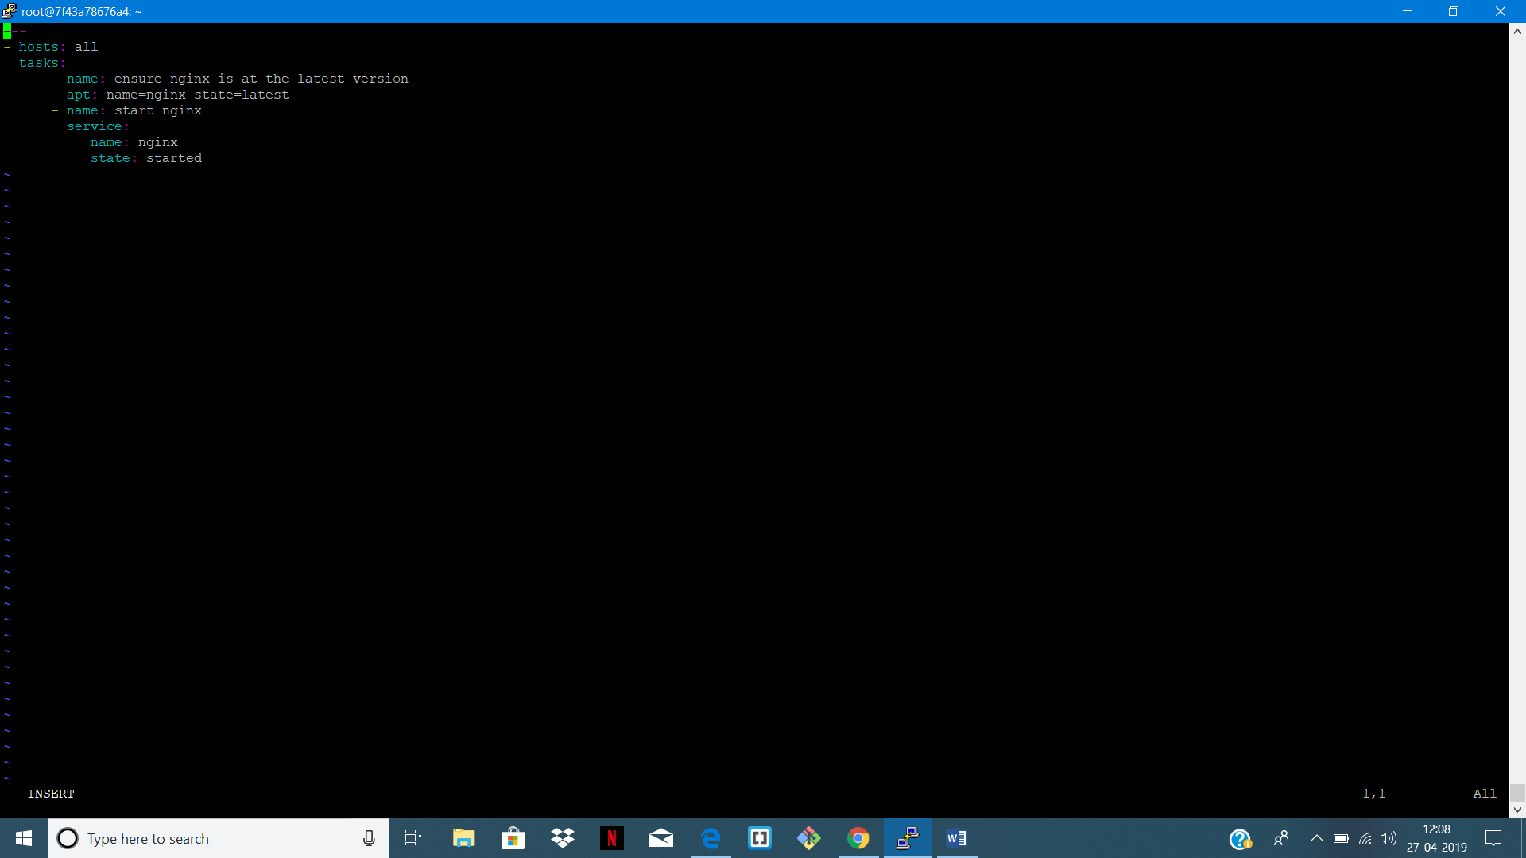

STEP 15: PLAYBOOK STARTED RUNNING

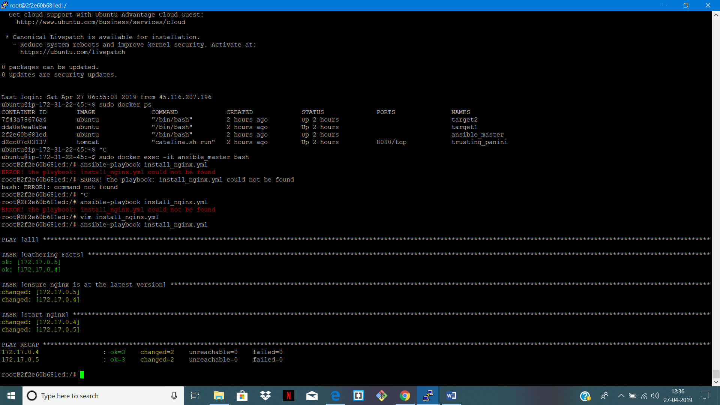

WE CAN SEE NGINX IS RUNNING ON TARGET 1 AND TARGET 2

FOR TARGET 1:

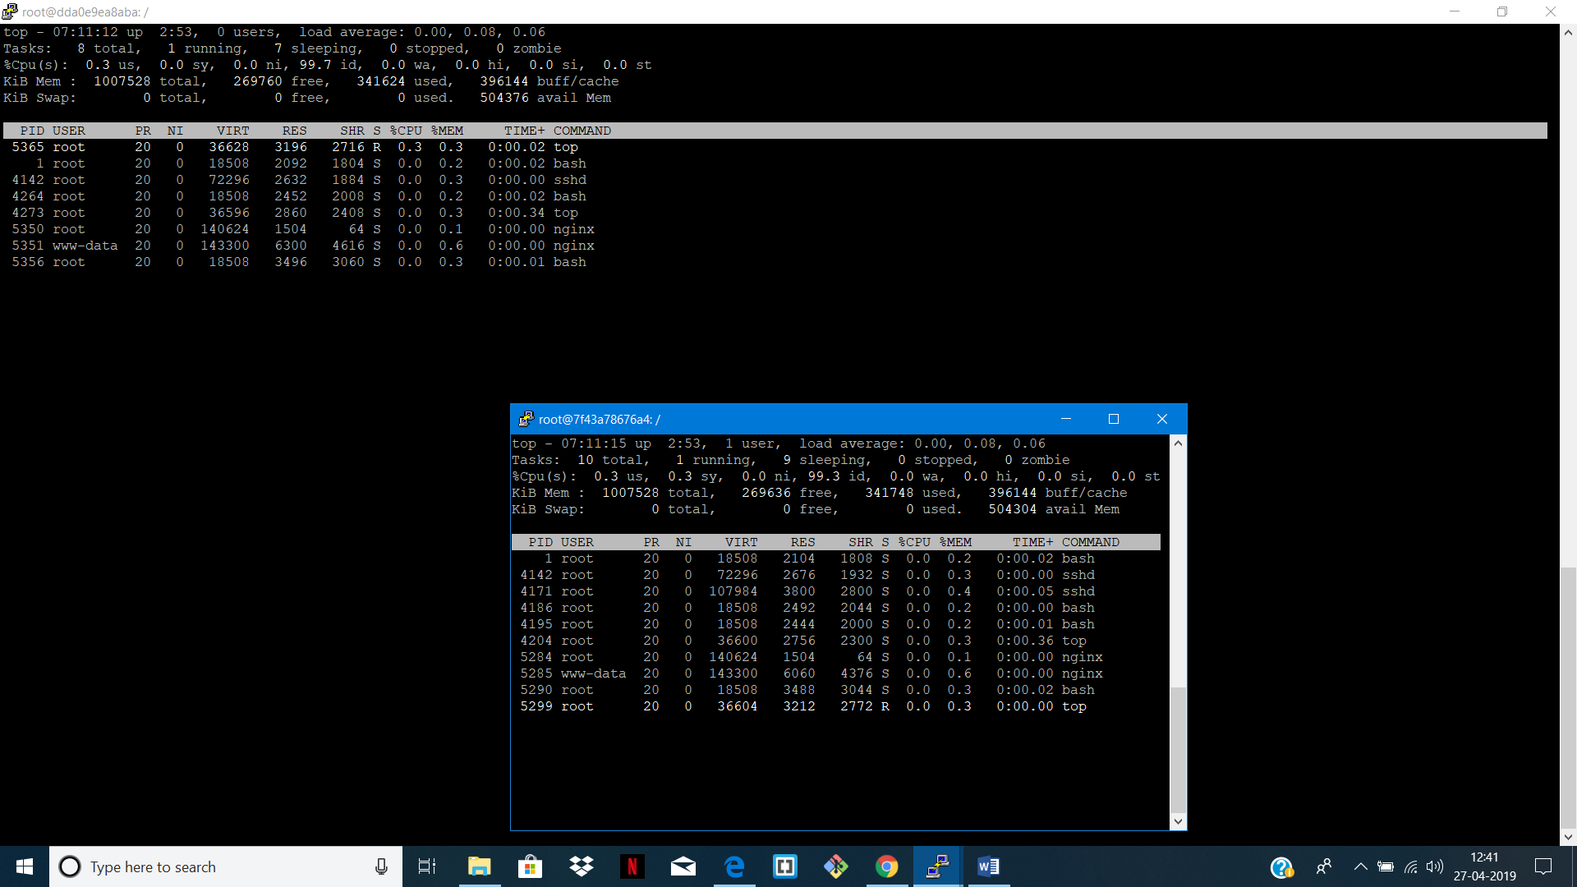

FOR TARGET 2:

